Low Speed Flow Past a High Aspect Ratio Wing Lab
Pre-Lab Notes
You should be familiar with Prof. Buxton’s lecture Chapters 1, 2, 3, 5.1 and 5.2 before reading this note
Swept Wing Lecture
Infinite swept wing
Only 3D influences arise due to sweep alone
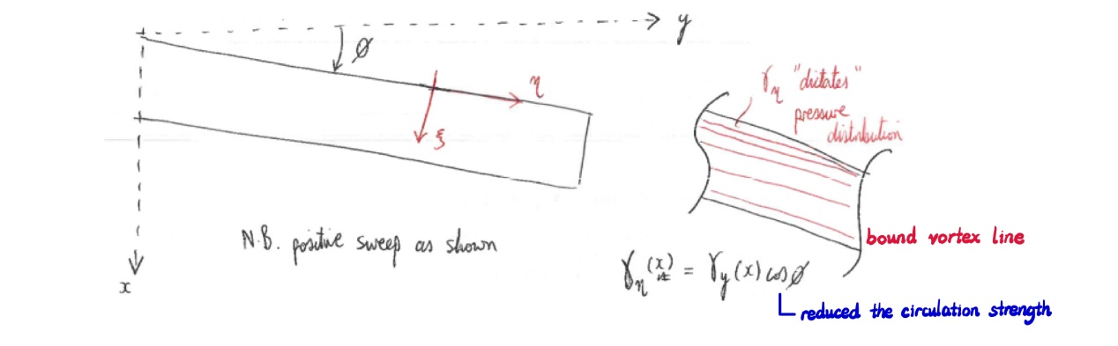Bounded vortex in the section of the wing
- Delay of $M_{crit }$in high-Mach-number subsonic flight, as the wing can remain subcritical
- Shock wave formation
- Flow becomes compressible
- Fly beyond $M_{crit}$ might reach $M_{DD}$ where wave drag increases dramatically
* Adding sweep also could result in thinner wing, which reduces ‘acceleration’ of flow on wing surface

- Velocity perturbation changes to $u_{ξ}=u_{∞}cosϕ$ and $u_{η}=u_{∞}sinϕ$
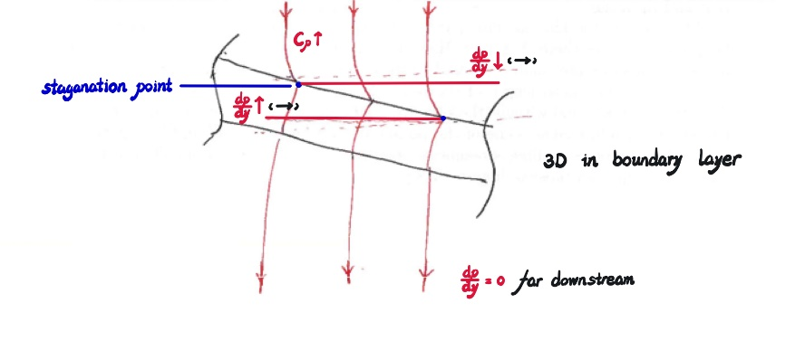
Streamline curved over the wing (non-zero pressure gradient being created)
* For wing of large$AR$, the conditions of infinite sweep almost meet at the half-wing
Finite aspect ratio
When$AR≥4$, we say it is large$AR$. When$AR≤3$, the effects at wing tip and root merge.
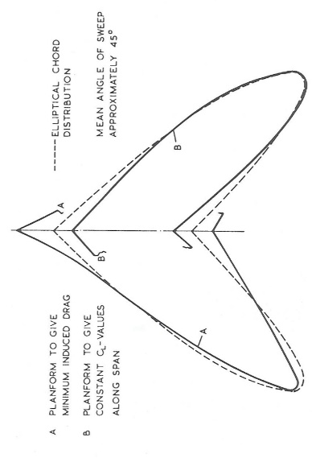
Platforms of minimum induced drag, constant lift and elliptical chord are no longer overlayed
– lifting line theory becomes invalid
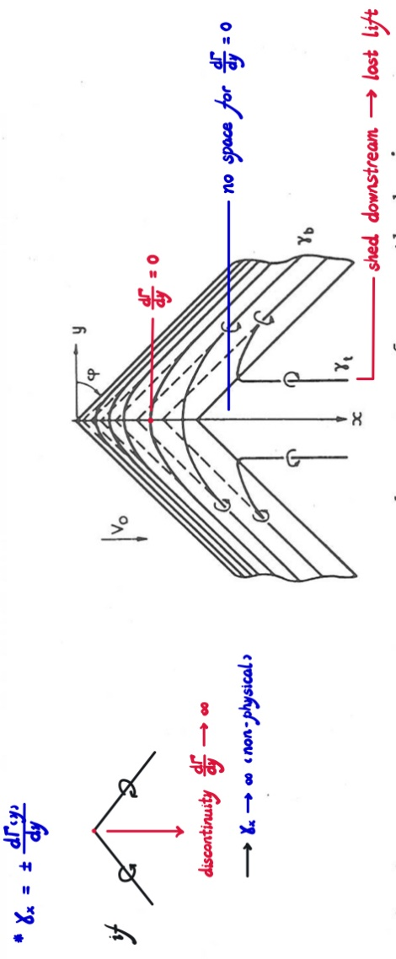
Vortex pattern near the center of a sweptback wing - Shed$Γ$at trailing edge
- At root
- Shed$Γ$at trailing edge - overall loss of lift
- Aerodynamic centre moves aft

- At tip
- Increase suction peak pressure gradient
- Aerodynamic centre moves forward
- Potential tip stall due to larger adverse pressure gradient (also because spanwise flow that pushes the boundary layer outboard) – results huge rolling moment
- Earlier sonic condition at tip than root due to addition of transverse flow
* Taper leading edge to overcome the last two issues
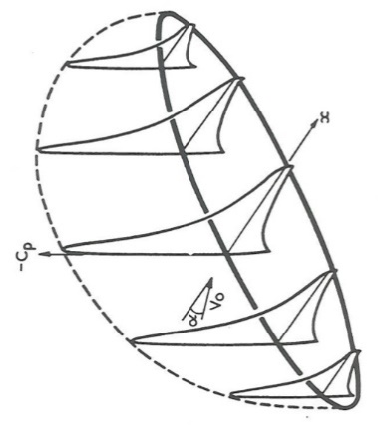 | 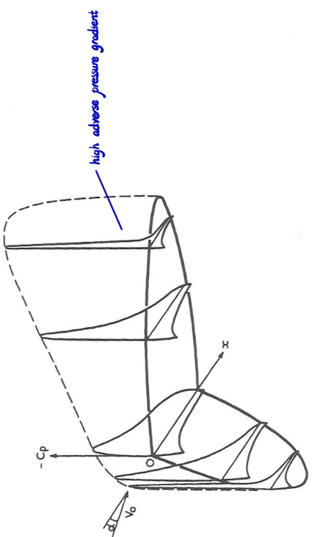
Pressure distribution over flat and swept back wing with the large aspect ratio
- Note how the effect of shed vorticity at the centre line is to push the pressure peak downstream, while the effect of the tip trailing vorticity is to push the pressure peak upstream.
As a result, the pressure drag of the swept wing is highest at the centre.
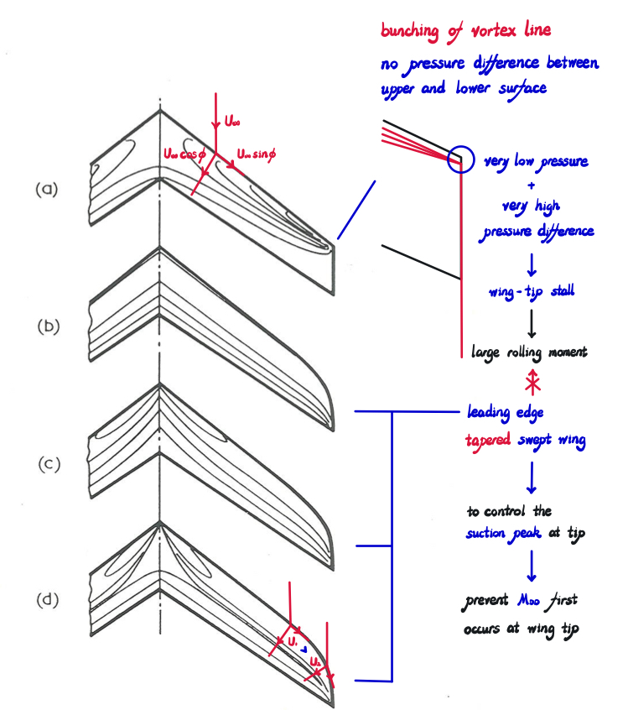
Effect of leading edge tapered swept wing

- Uniform taper
- Reduced lift at the tip - smaller chord at the tip
- Reduced risk of tip stall - aerodynamic load is shifted more towards the root
- More elliptical lift distribution
- Counteract the adverse effects of spanwise flow

- Linear Twist (Washout)
- The root section of the wing will reach its stall angle before the tip - reducing the effective angle of attack at the wingtip compared to the root
- Potential tip stall due to larger adverse pressure gradient (also because the spanwise flow that pushes the boundary layer outboard) – results in a huge rolling moment
- Counteract the adverse effects of spanwise flow
*Will tip stall first in our experiment?

Surface Source Singularity (Panel Code)
Method
Assume incompressible, potential (inviscid, irrotational) flow
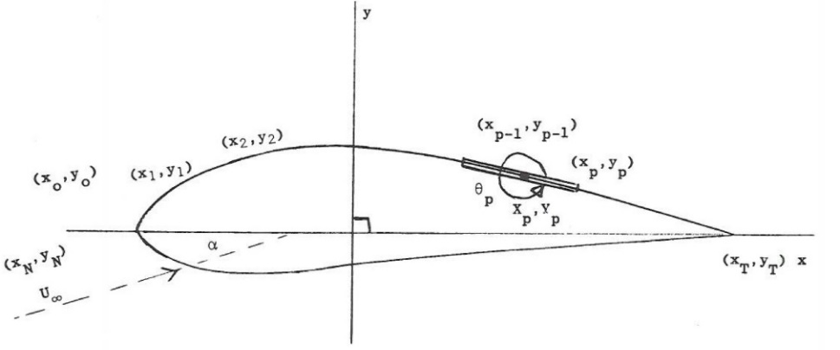
Divide the surface with various points connected by ‘panel’ with source density$m$
– One of point must be the trailing edge if body is airfoil

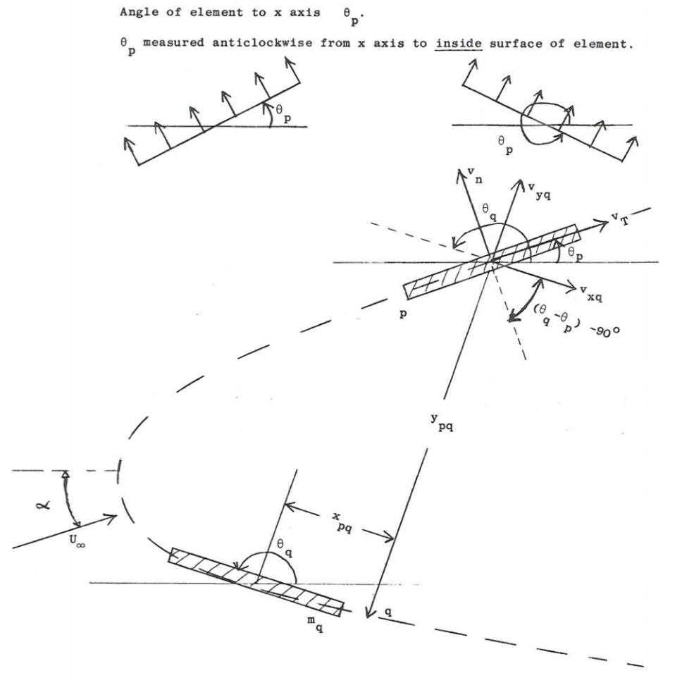
Body coordinate system

- Find velocity components at the control point of the p^{th} element due to the q^{th} element
- Find $v_{xq}$ and $v_{yq}$ as function of $m_{q}$
- Find normal velocity due to the q^{th} element at p^{th} element $v_{n}\left(p, q\right)=A_{p, q}m_{q}$
- Find tangential velocity due to the q^{th} elemen at p^{th} element $v_{t}\left(p, q\right)=B_{p, q}m_{q}$

- Find velocity components at p^{th} element due to free stream and AoA
- Find free stream normal velocity at p^{th} element $U_{n}\left(p\right)=U_{∞}sin\left(α-θ_{p}\right)$
- Find free stream tangential velocity at p^{th} element $U_{t}\left(p\right)=U_{∞}cos\left(α-θ_{p}\right)$

- Compute source density at p^{th} element
- Normal velocity at p^{th} element $\sum_{q=1}^{N}{v_{n}\left(p, q\right)}+U_{n}\left(p\right)=0$(linearized boundary condition)

- Compute tangential velocity components at p^{th} element
- Tangential velocity at p^{th} element $Q_{p}=\sum_{q=1}^{N}{v_{t}\left(p, q\right)}+U_{t}\left(p\right)$

- Find additional source density due to the application of the unit circulation $Γ=U_{∞}c$
- Normal velocity at p^{th} element $\sum_{q=1}^{N}{v_{nΓ}\left(p, q\right)}=U_{nΓ}\left(p\right)$

- Find number$k$ of unit circulation that fulfills Kutta condition at the trailing edge
- Kutta condition is $Q_{T}+Q_{T+1}={∆Q}_{t.e}=0$
- Therefore, ${k∆Q}_{Γt.e}+{∆Q}_{t.e}=0$
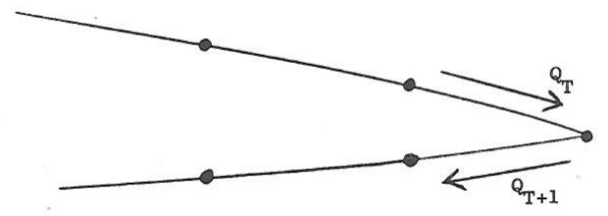

- Find the surface velocity at p^{th} element by superposition
- Normal velocity at p^{th} element $\hat{Q_{p}}=Q_{p}+kQ_{pΓ}$
- Pressure coefficient at p^{th} element $C_{p}\left(p\right)=1-\frac{{\hat{Q_{p}}}^{2}}{{U_{∞}}^{2}}$

- Find lift coefficient
- Life coefficient $C_{L}=2k$

Pros and cons of using panel code estimate swept wing aerodynamics
- Linear boundary problems can be computed when viscous effects are either unimportant or can be dealt with in a simpler way such as by the addition of a circulation
Pros:
- Simplicity
- Faster Computation by avoiding the computational complexity of full Navier-Stokes or boundary layer models
Cons:
- Cannot accurately capture flow separation or stall behaviour due to boundary layer detachment
- Poor drag estimation - pressure drag and skin friction drag are not directly accounted for by inviscid panel codes
- Complex flow interaction on the swept wing, involving spanwise flow, adverse pressure gradients, and tip vortices, panel code cannot fully capture the complex interplay of 3D viscous forces

- Lifting problem in 3D
Cons:
- Very lengthy iteration processes are needed to obtain the correct position for shed trailing vortex wake
* Test the accuracy of the panel code by changing the number of elements around the airfoil (A.M.O Smith suggests 3D bodies 500-1000 panels)
** Curved elements can be used for 3D bodies for more algebra but fewer elements

cd "C:\Users\GH-X-ST\OneDrive - Imperial College London\Year 3\Aerodynamics 3\A - Low Speed Flow Past a High Aspect Ratio Wing Lab\01 - Lab Files\panel_code"
Measure-Command { .\combo.exe mesh.dat auxiliary.dat stream.dat sect inp }

Effect of resolution
- Chord-wise discretisation
- Finer discretization leading a more accurate lift calculation, as described the shape of the airfoil

- Span-wise discretisation
- Diverging occurs at the wing tip when the number of span-wise discretisation is smaller or equal to the number of section ( 3 section in this experiment)
Experiment
Procedure
- Read Pressure
- Set wing to $α=0°$
- Record manometer readings to data.xlsx
- Repeat by set wing to $α=6°$ and $α=13°$
*Change AoA gradually to avoid the stepper motor stall (when the motor does not have enough torque to overcome the load when accelerating/decelerating too fast)

- Stall the wing
- Set wing back to $α=0°$
- Increase incidence
- Record incidence at a stall by observing the wool tufts and pressure distribution
- Make sketches of the qualitative shape of the pressure distribution for each of section
*Wait some time to make stall progress throughout the wing before recording
**Try to record different threshold value of AoA for tip and root stall
*** Stall angle for infinite wing in [3] should be 17 degrees

- Wool tufts
- Post stall - lie smoothly along the surface of the wing while pointing slightly outboard due to the spanwise component of flow
- Tip Stall (which is expected for swept wing) Initiation - wool tufts near the wingtip will flutter and oscillate
- Separation progresses inboard
- Full Stall - wool tufts across most or all of the wing will be flapping wildly
*Record videos of the wool tufts at above experiments and add screenshots to the PowerPoint

- Pressure distribution at different AoA
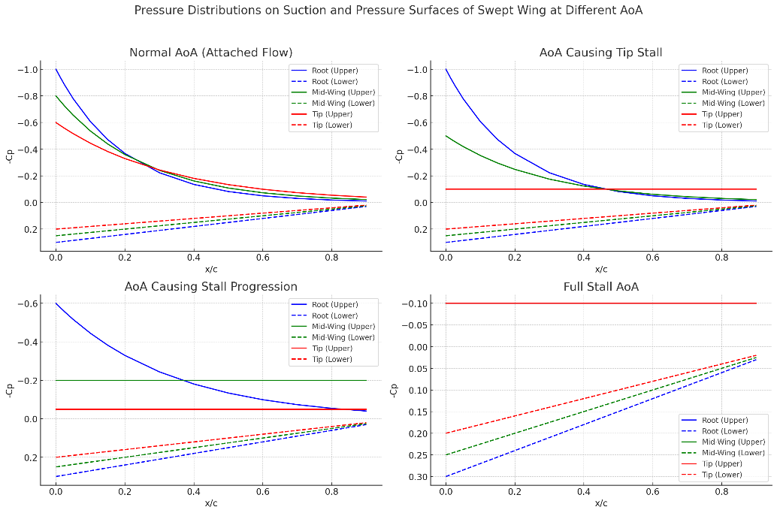
Expected pressure distribution at different AoA
Conclusion
- The influence of sweep and infinite aspect ratio on the sectional lift-coefficient slope of a swept wing, is panel code a good approximation?
- Provide plots in MATLAB for swept wing
- Record manometer readings to data.xlsx
- Repeat by set wing to $α=6°$ and $α=13°$
*Change AoA gradually to avoid the stepper motor stall (when the motor does not have enough torque to overcome the load when accelerating/decelerating too fast)

- Stall the wing
- Set wing back to $α=0°$
- Increase incidence
- Record incidence at a stall by observing the wool tufts and pressure distribution
- Make sketches of the qualitative shape of the pressure distribution for each of section
*Wait some time to make stall progress throughout the wing before recording
**Try to record different threshold value of AoA for tip and root stall
*** Stall angle for infinite wing in [3] should be 17 degrees

